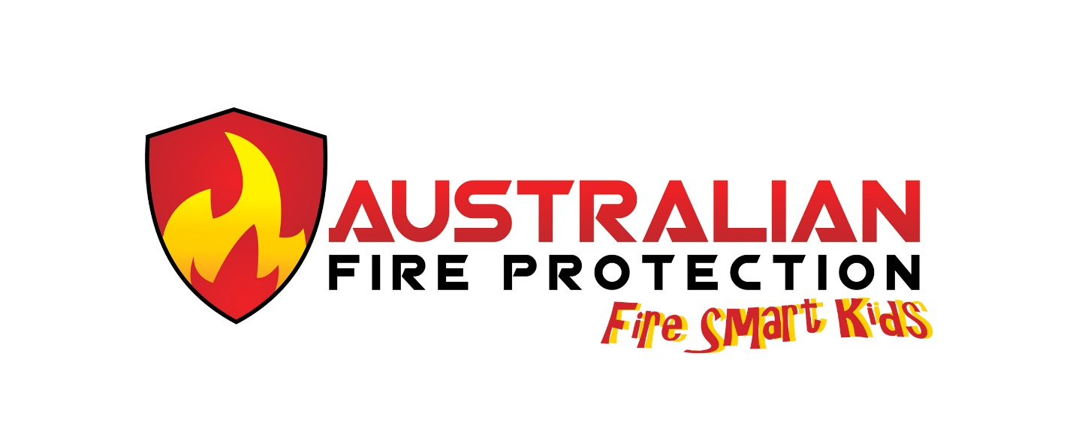

Fire Smart Kids Program Guide
Lesson Plan for Presenters

Fire Smart Kids - Overview
The Fire Smart Kids Program offered by Australian Fire Protection is a resource available to Childcare Centres and Family Day Cares in order to prepare children for emergencies. This delivery requires interaction with Trainers/Educators to simulate potential emergencies in either their homes or other venues. The training was developed to prepare 4-5-year-olds in the case of a fire emergency but can be adapted for any age group and emergency. The goal is for all children to have fun in learning.

Disclaimer: The training material and training published in this document is for general information only and is intended to provide helpful and useful material on the subject in the training. Whilst Australian Fire Protection has made effort to ensure accuracy of the information there is no guarantee that this information will be absorbed by the individual learner due to their age or the delivery of the training is accurate by the Educator.

Workplace Health and Safety
Before commencing delivery, it is recommended that the Trainers/Educators ensure that the environment they have chosen to deliver the training is safe for children to participate and has space to complete some of the interactive activities. We recommend that you:

- Ensure that a risk assessment of the training area and that adequate space is provided prior to the delivery of each Fire Smart Kids program.

- Ensure that all equipment being used in the training session has been checked and is in good working order and cleaned ready for use (if applicable).

- Ensure all personnel have completed an assessment and their role responsibilities before commencing.

- Site area and statutory safety requirements should be observed at all times during the training.

- Where applicable, all Personal protective Equipment (PPE) appropriate to the task should be worn.
Pre - Instructions for delivery of Training
Required Resources: | - A large cut out image of a fire  - A larger grey sheet to represent smoke  - Home Smoke alarm for children to be able to touch  - Home smoke alarm sound (or simulated) – this can be downloaded from the resources provided or resourced from any app that provides a simulation of the sound  - Your Equipment used for Evacuation of Fire. Eg whistle, fire alarm (simulated) or airhorns  - Projector for power-point display/or other visual aide such as laptops  - Stickers/ a reward for the children (if applicable)
Presentation Participants: | It is recommended that the following roles are designated depending on the size of the numbers of children participating.  For smaller groups this can be completed with 1 Educator and students participating in the designated roles.  For larger groups, consideration for the following roles may be required:  - One Trainer/Educator to conduct the presentation  - One Trainer/Educator to address children for the fire exercise  - Additional Trainers/Educators to help maintain the children’s attention
Links for Presentation: | Australian Fire Protection have used the following videos to address important points for preparing for emergencies, however, these can be replaced with other examples if the Trainer/Educator finds resources that is more suited for their learners.  Butterscotch TV, “Get Down Low and Go, Go, Go” YouTube. (1.29 mins)  Fireman Sam US, “A Song About Fire Safety” YouTube. (0.00-1.32 mins)  NSW Ambulance, “Teaching Kids About Triple Zero” (0.33 mins)
Timeframe for delivery | We anticipate the full delivery structure as follows:  - Set Up: 5-15 minutes - (includes preparing and having video content available or setting up the room with projectors if presenting to a larger group.  - Presentation: 40mins – The delivery and content and allowing time for interaction  - Pack Up: 5-15 minutes – Again this depends on the size of group and equipment sued
Sound Precautions | An important point is to ensure that any of the learners in the group is not going to be affected by the tones used for smoke alarms. Some Learners may have sensory sensitivities that need to be considered when introducing sound. Ensure you test the sounds for alarms prior to using the first time.
Videos | If you are getting a black screen on the slide, move your mouse or click on the black screen and this will bring up the play bar. Select play to proceed.

Lesson Plan
Session - Introduction |  | Trainer Script | *Action/Resource
Allow up to 5 minutes for the Introduction. This can be shortened depending on interactions and responses with children. | Presenting Trainer/Educator | Today I am going to talk about Fire Safety and help you all become Fire Smart SUPERHEROES!  Who wants to be a Fire Smart Superhero? *  Great, because at the end we will be giving out stickers to the kids that listen up, and help us (if applicable) | Refer to Slide 1  *Prompt Responses
 |  | Are you ready!? * | *Prompt Responses
 |  | Who can tell me which of these is a fire? * | Refer to Slide 2  *Prompt Responses
 |  | So, most of you would know that this one is the fire, right? * | *Point to Image of fire  Acknowledge and reward Learners as appropriate.
 |  | Now, let’s talk about what to do if you see a fire at Kindy or home.  Fire can be dangerous, so we don’t want you to go near it, because it is very hot, and we don’t want you to get burnt.  Who can tell me what they would do if they saw a fire?  Those were some great answers! | *Prompt Individuals
Session – Fire, Fire, Fire |  | Trainer script | *Action/Resource
Allow approximately 5 minutes for this section. This can be shortened depending on interactions and responses with children. |  | So, the first thing to do if you see a fire is yell ‘Fire, Fire, Fire!’  Would you like to try that with me?  Okay on three we are going to call out with our loudest voices FIRE, FIRE, FIRE  Ready? 1,2,3… | Refer to Slide 3  *Prompt Responses
 |  | Good work, but I think we can be louder than that.  Let’s try again on 3!  1, 2, 3… | *Prompt Responses
Then the second thing you must do is tell a grown up

We then listen to the teacher and line up.

And the last thing to do is Exit/leave the building as quickly as possible without running.

But if you are at home you would just follow the adult to exit.
 | Presenting Trainer/Educator | Okay, I am going to show you what I would do if I saw a fire.  I’m going to need some helpers.  One to hold the fire and the other to be the teacher. | * a Learner to hold fire  * a learner could take on the role of the teacher
 | Presenting Trainer/Educator | “Fire, Fire, Fire!!!!!!!!!!!  Miss there is a fire over there!” | Presenting Trainer/Educator demonstrates actions for learners
 | Presenting Trainer/Educator | “Okay everybody there is a fire!  Let’s quickly line-up and carefully walk out together.” | Presenting Trainer/Educator demonstrates how they practice the Evacuation to either the staging or holding areas
Session – Fire & Smoke Alarms |  | Trainer script | *Action/Resource
Allow approximately 7 minutes for this section. This can be shortened depending on interactions and responses with children | Presenting Staff Member | Who knows what a Smoke alarm looks like?  This is a Smoke alarm that you may see in your home.  A Smoke alarm makes a loud noise when it detects smoke and it sounds like this.  Optional: If you use a specific sound to Evacuate in the centre please use this to simulate the sound that you would use to Evacuate the centre. For example, you may use a whistle, or have an airhorn. | Refer to Slide 4  *Prompt Responses  *Initiate the Home Smoke alarm sound.  You can also demonstrate a Fire Evacuation alarm sound and explain the difference.  Note: Please test the sound prior to use for children who have sound sensitivity.
 |  | If you hear the fire alarm go off you would listen to your teacher, line up and exit.  So, what do we do if we hear this?  Acknowledge responses.  This happens because when there is smoke in the room the alarm senses the smoke and makes the really loud noise so that everyone can hear it. | Refer to Slide 5  *Sound alarm again.
 |  | If you see smoke in the room what you need to do is  tell a grown up and then we  get down low and go, go, go! | Refer to Slide 6
 |  | Let’s now jump to our feet and have a have some fun by getting down low and go, go, go | Refer to Slide 7  Action: Get your smoke sheet ready. You may need to have either 2 Educators one at each end or have children take turn to hold the ends of the sheets.  Play the following Video and singalong  *Butterscotch TV, “Get down low and go, go, go” Youtube (2.42 mins)
 |  | Great Job everyone! Now you know that:  when you SEE a fire, you yell…  Fire, Fire, Fire!  When you HEAR a fire alarm you…  Listen to your teacher.  And when you SEE smoke you yell  Smoke, Smoke, Smoke,  And then you…  Get Down Low and Go, Go, Go! | Refer to Slide 8  Action: Summarise and reiterate the actions to children
Session – Drop and Roll |  | Trainer script | *Action/Resource
Allow approximately 5-7 minutes for this section. This can be shortened depending on interactions and responses with children |  | Let’s watch a video with fireman Sam about what we do if our Clothes catch fire! *gasp*  You can encourage movement with children with this video | Refer to Slide 9  Fireman Sam US, “A Song About Fire Safety” YouTube. (0.00-1.32 mins)  Note: you can stop the video once they have finished the stop and roll.  Action: You can encourage movement with children with this video
 |  | So, if our clothes caught fire we would:  Stop!  Drop, cover our faces and Roll!  I need five volunteers to help me show everyone how to stop drop and roll! And the best one will win a sticker!  Ready, here we go:  Stop!  Drop, Cover your face and Roll!  Great Job Everyone, one more time  Stop!  Drop, cover your face and Roll! | Refer to Slide 10  Action: Educator to demonstrate  Action: Educator to select 5 children to participate  Action: Educator to demonstrate  Action: Children to Demonstrate
Session – Phone for help |  | Trainer script | *Action/Resource
Allow approximately 5 minutes for this section. This can be shortened depending on interactions and responses with children. |  | Does anyone know the number to call if you need help from a police man, fireman or an ambulance and there is no grown up around? | Refer to Slide 11  *Prompt Responses
 |  | We would call 0-0-0! | Refer to Slide 12  Action: Play the video about calling 000  NSW Ambulance, “Teaching Kids About Triple Zero” (0.33 mins)
 |  | To call 0-0-0 we hit the zero button three times and the call button.  But we would only do this if there is NO GROWN UP AROUND and there is an emergency - if someone else is seriously hurt, or in danger, or there is a fire.  But if there is a grown up tell them what the emergency is and they can call the police, firemen or ambulance for you. | This section can be explained by the Educator in a variety of ways that is adapted to the Children’s learning skills
Allow approximately 5 - 15 minutes for this section. This can be shortened depending on interactions and responses with children.  This allows children colouring time for the certificates. |  | Congratulations, you are all now Fire Smart Superheroes! | Refer to Slide 13  Action: Educators to hand out the Fire Smart Kids certificates and can spend the next 15 minutes colouring in.

Thank you from the team at Australian Fire Protection for completing the 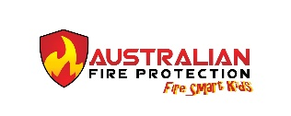program.

